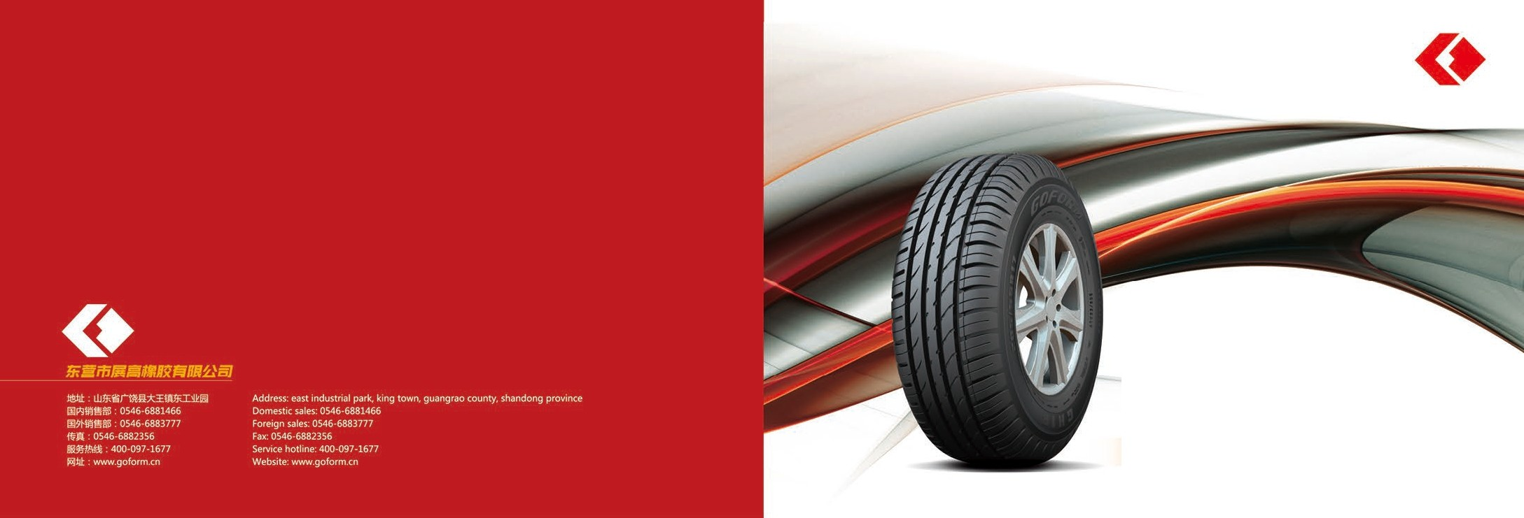

. @ *z* ft */Jb /XL fj* ;Ji2 .

*CHARM FOR GOFORM TIRES*

***OOFORM/FOMFIN***

' *' f/UJ :f. ffi/Jtj SUVi!lff JU* @ /Jtj *i!sit!!Dtf*

**COMPQNY *PROFILeS***

$'Efm 11o mH m EJrn':F1994iF, rB iiiimmA9 ;oJ: H.1iffl- tlIn<r m:k :ElF-ll tm18:. Ji¼-eii:fflt M; ;i;, ii, mm'f-¢-8:J:k

!11 &:l'.ill. a.lolt!J30i5ll'n*, I2.000 .A., M.1JJ ttlm?l!lli!l'r /lti, illll/,8':l Ff!J g.

""*·

2009$5J=rniFffcF1,200i5ffiWitt ?l!Uil f.!Ueffl §, -1Vl6007'iff':F2011ffc3/:JIW"', = WlD /ff 2013$ 6FliH t* F . §ll1J, *J'f-',gffl*

mil, 1:F- Sll1 tt!l1&. ifli EJ:Jlll<j ' fll:, g,, Ii - i,; ·

**COMPQNY *HONOR***

O2016cpOO l¥cla: mg

fl) , s lffl%iltA9$8 V"iOli iJli'lr, ffl □ l1 A9 F lMt IDF 86tf :/it l!,I-, ,,8Pl/tiltli , iJ ff.Jllt.:l: $81¥clrai..

m l$. 'f,Jiia a.11:1a;a:m1,2oonR, ?l;l!l!Fm301z, F,\'l,iiWJ©;OO,

J'f-M'm/ll«ilifflHill& E.Jmm "ll!lf.ilffi-, m-· A91¥<l1i, /t.,ttM!,i i1Hi!ffi!€1Y:JJJDA, ;t!; *I

Doogy,ng Zhangao Rvllber Co.,Ltd was eslabisheO ., Dawang /ndusuy Sllandong Prow,ceof beaubfut andnch Yelow Delta In 1994,IS a i,e research and develol)menI

'"l'"'" tc""'() ..-">S on ¢<'9 of 1"(()9 =: ..Of''. - T OOMl)<'Oy ,:,,;,:,,op,(>';*'.Y:-0,(){)()* sq,,..,,,., Mel'?'$, """ .. tn.-n 2,(){)() "" (>(l(l"(J'.'Q ,n h'(Jh-P')(f

semi-steelrad<alt>re,1heproaucooo and0pem1JOn of111ei,e.

Doogyw,gZhangaoRubbe<Co.,Lld pul 1nlo Ol)eral,00In May2009,VAlh*an* annualwlpulol 12mdlonsetsol hlgh-pedormaocesem-steelradial reprojecl,a 600mdllon**lnls**

put ,nI0Ol)<)l'allOn ., March 2011.111e second J)hase*ol* the pro;ect ,n June 2013 lormaiy rM intooi:,e,at,on A1 presen:, Do<,gy,ng Zhangao Ruooer Co.,Lid has *an* annual capad1)1or 12 sots.!he 001p<n value ol 3 bollioo, the oroduciS aroeJ<P<)rted toEurope andlhe unned Stetos. 1110.V.clclo Eas1, Alnca. Southeast Asta anaother regooos

"""'°"

O;ij g!i m l\L

0 /j\ l!l.jrr

OT]'f; l1slillffiiffll1 0 5tinll lii!S'U§!R

OCh,na tre enterp,ise ranklng,n 2016

oCustomer satisfaction ur>I oP nma,ymember un,t

ZhangaoOC)fl'!,any adhere 10 **the** "lowcal1JOO, green, elfoon1.enwoomenlaRy fnendly'p<irlOj)IO. 0100acvanceo lireproouct,oo anoIos1.rog

t, empi()ylng v,ell-known

OP ro tect oootracl8J1dcredit ente,prise

eote,pnses of proctuct,o,, technotogy anoP<OdUCI devel0t)meoI team, *co*provide customers with sate.com!or.atlle high-perlormanoe 9<eent,reproducts

Dongy,,g Zllangao f bbef Co.,Ltdadhenngto the•qually f.rsl.servicefirst•purpose,warmly welcomelne ooomun.ly toJOG1 the et1e,crea1e bnloant Mure!

OAdvancedp,vnary party organizaliofl

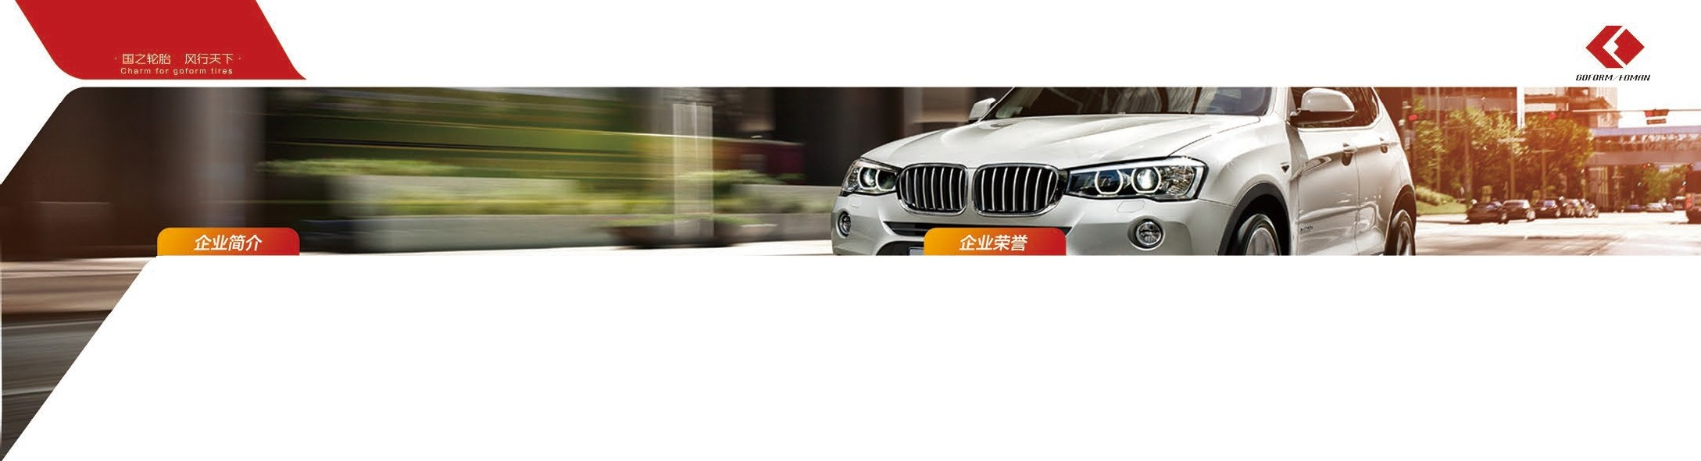

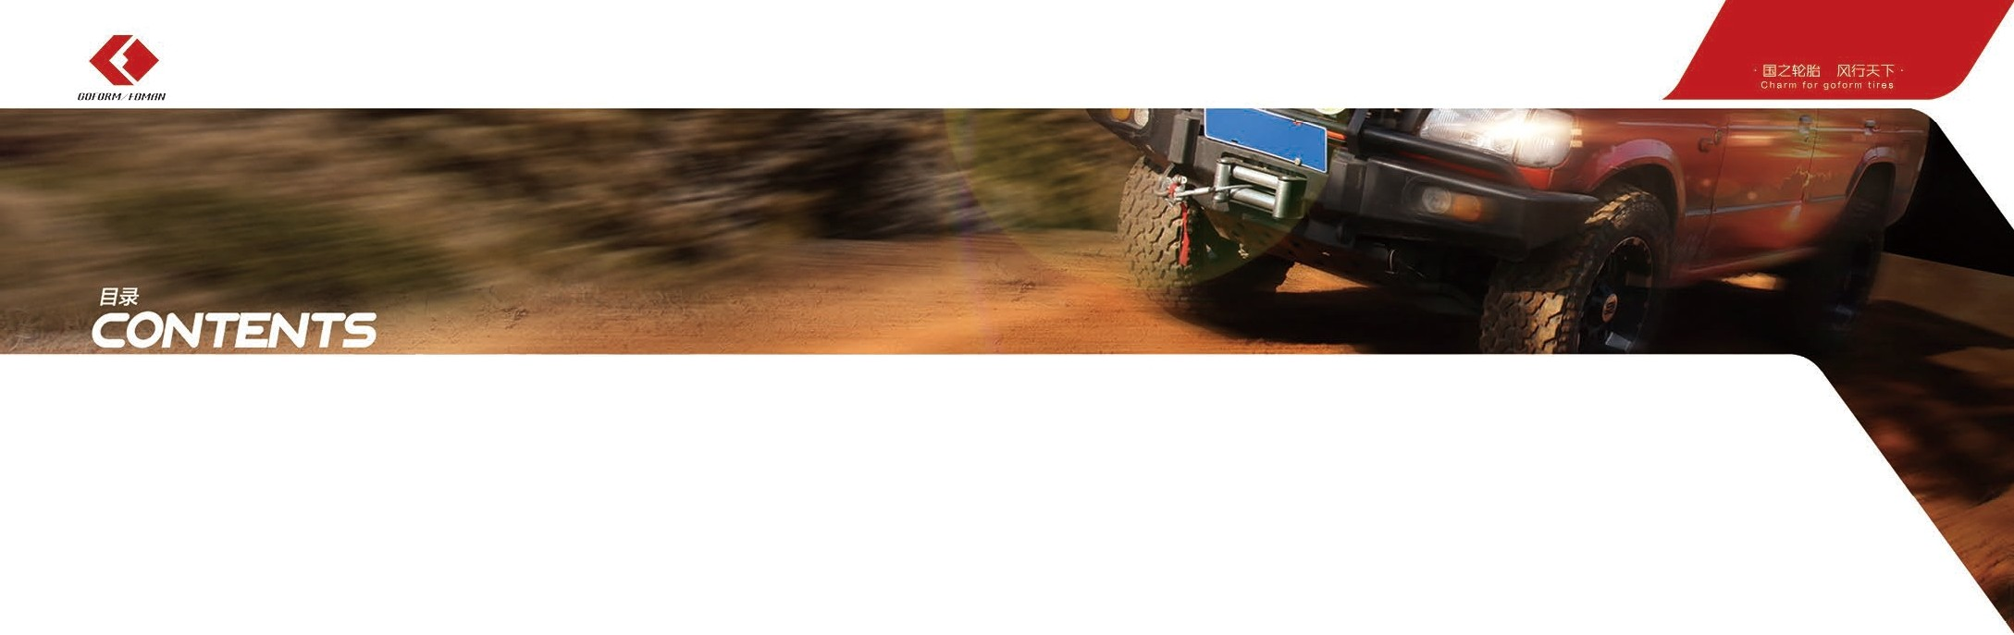G - 520 ....... .....•. ........... ..... ...• ............................ ..• 01/02

G- 745 03/04

G- 325 ........... ..•...•. .... .....• ....• ........ ..... ..•....• 05/06

G- 668 ...• .... ......... ..... ... ....... ......... ..... .• 07/08

GH18 09/10

ECOPLUS HP ...... ..... ............ ..... •...... ..•......... •.... •...•. 11/12

ECOPLUS SUV 13/14

AT01 15/16

GT02 17/18

GS03 19/20

GF50 21/22

GM02 ...................• .•.... .....• ......................... .......• .... ..•..•.• 23/24

W705.•..•. ...... ... ................... ..... ..•.........• ....• 25/26

W766........ •.•..•...•.. •.•.... ..•.. •...... ..•..•. ..•.. •.•.. •...•.. •.•.... ..... •.•. 27/28

W6 96 ... ............ ..... •...... ... ......... ....... .......... ........... ... ..•....•. 29/30

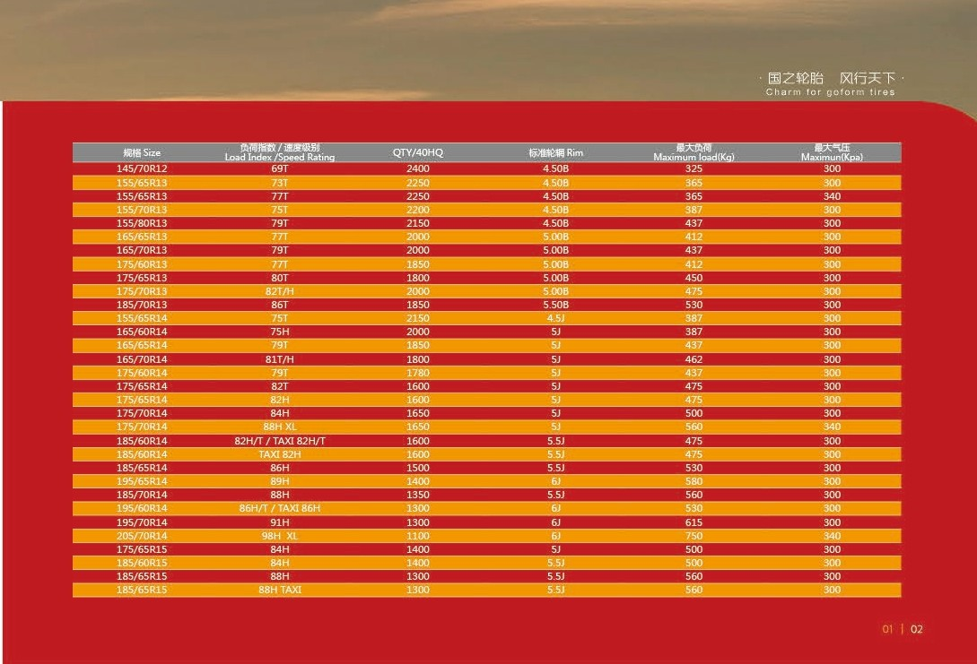



***/ill/ IIHM f/lMIIII***

# G-520

***m$$W-=:r!fllft***

Passenger C::ir Tires



* oo ren& TT. $ m

1Jllffi tt f0:i!!JJO:±lfs Mtff litt. ::f/JlJIJJ!lt G520 i':E'f; f»Wl> i'l'""F.6t tllfsllllll!!ttfcila1JH;rn$ 11, :!ll:<iJ>..J. ilit: ;l!im* \% /ii - W: t:all!l.

* + The unique formula and pattern design of the tread compound makes the vehicle more precise control and excellent silent comfort. Not only that, but the GS20 is excellent in both dry and wet conditions, as well as silencing. It is a kind of high comprehensive performance tire that can bringjoy to driving fife.

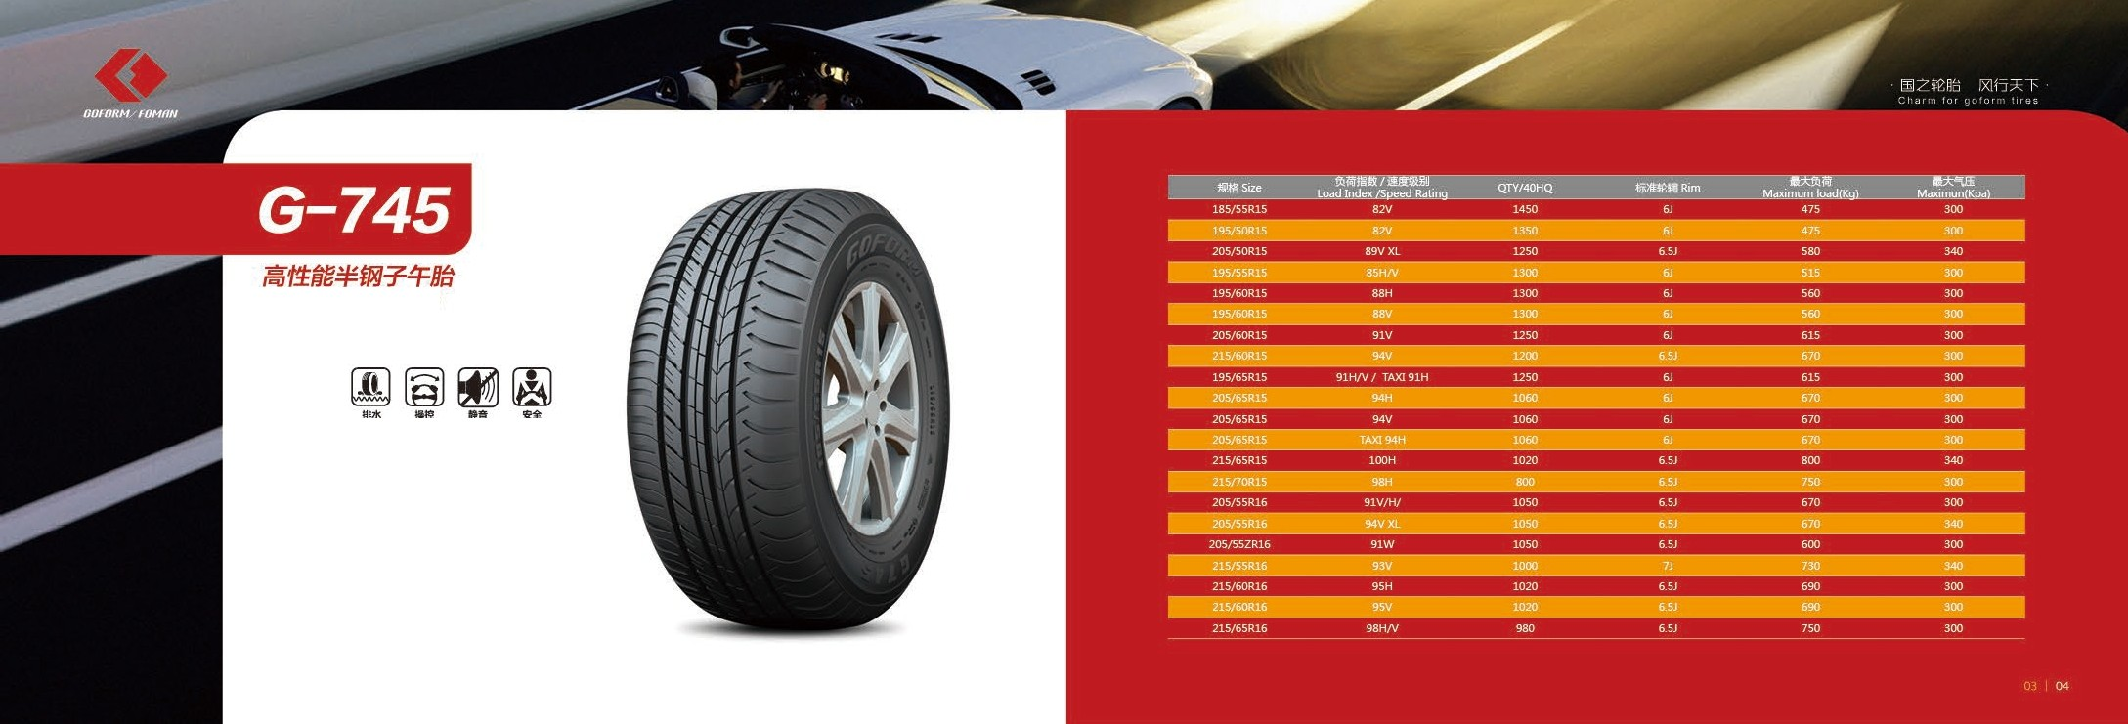

*High performance* tires

* ii!fi !J« 'l!t Mt1 ;
* -lf;i;JJ!i! ti?;llf'l t1- Mt1. =f illitt lt

1. \ii.t ;

* lii :o ,m t1fflll,M , ff ,Pit

fltii;;/JIWJ , f!.I.,HmfiH .

* Betrtedriivngand handing performance.
* The pattern is specially de signed for improving the

**performance of driving, controlling and dry wetland.**

* Silico n -containing formu la improves control and **braking performance, reduces noise, reduces rolling** res istance, reduces heat generation and increases range.

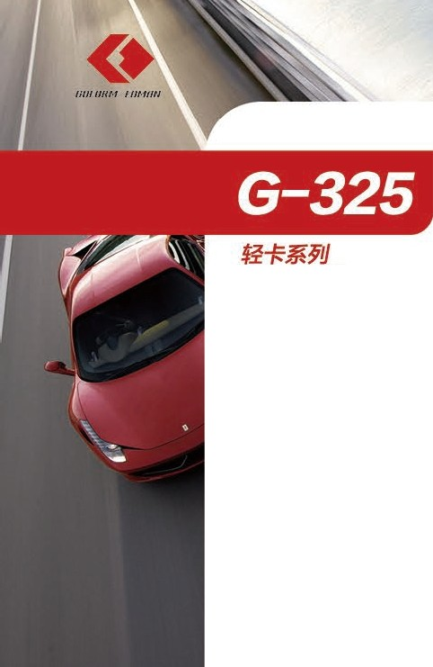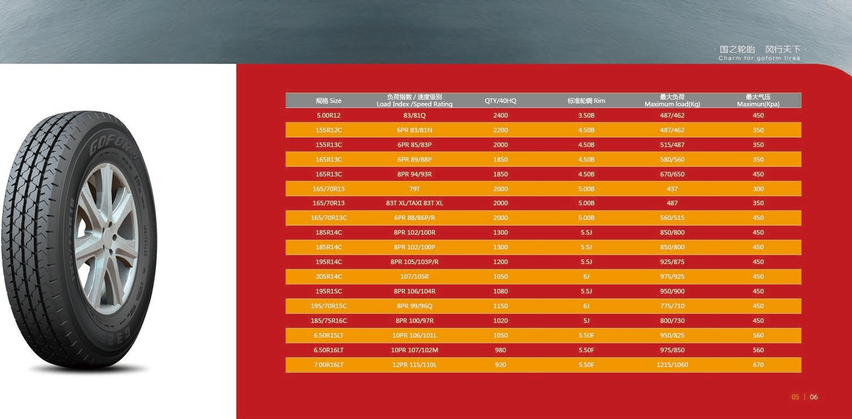

I *1qht Truck Tires*

* milf'lf,j i.t ' tlm lt!;ltJ ;
* ff/$ilii ffi' mDJ:ll;
* 'l\m:ii6'.1Hn ;
* ii£ g' ffl ;!!liii.t.
* The wide shoulder design enhances wetlan d grip.
* Super-wide tread contact drive smooth, comfortable and tire durable.
* Special wea r-resistant formula.
* Low noise and low fuel consumption



*(i /) / l/HM/ /·I/M f/11*

# G-668

#### 1Bif6ffl i!l

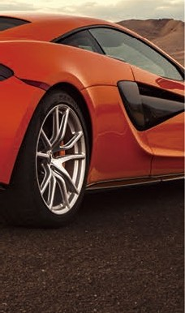*"uoerabras,on* .<;er,es



* fi '-1'1>llilii a& t

a:f*liE::l%l fl9it tt . !li;tji!Jti.'Jl:R*fl9 MciJili

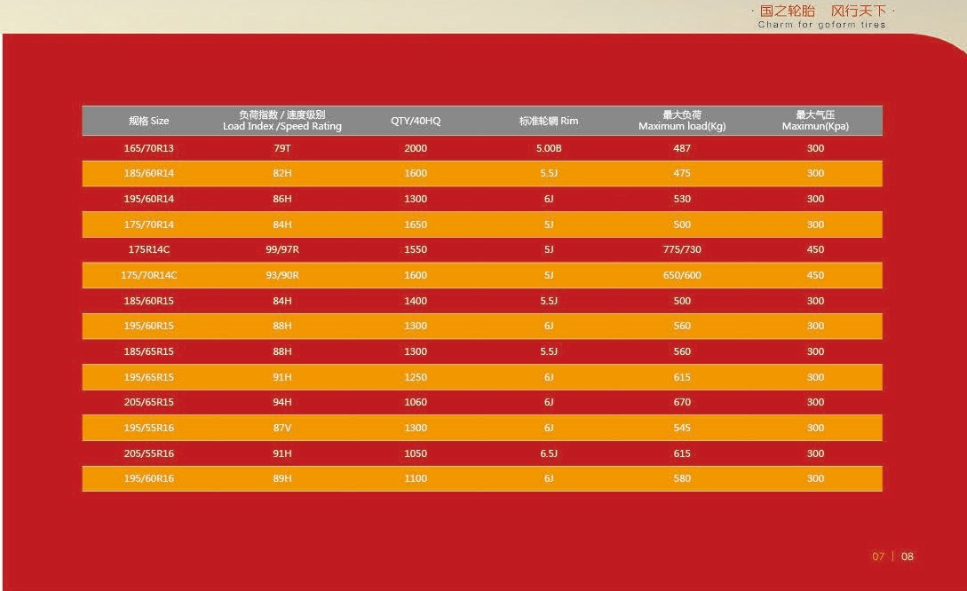

atJU l1 m1;

* + **:i!!* llUi . :il!M/1**

Mliffi 1.iH «: . !IJt/l ,iMlRJl!teB itillf.t;

* **ii .Ill, ttfltitt:**

###### ffm* ttfl9 - 7 ffi$ - -

It

* + lsspecificall y designed for Chineseroads

[n addition to ensuring excellent d urability, the comfortability and reliable control performance of the veh id es and vehicles can be imp roved to the greatest extent.

* Lo nge r mileage. more wear - resistant

The formula of tread rubber is optimized to improve wear life a nd ensure longer form distance.

* Is safe and durable wit h high performance

While improving the wear resistance, it meet s the e conom,ic safety and mane uverability requirements of compact cars.

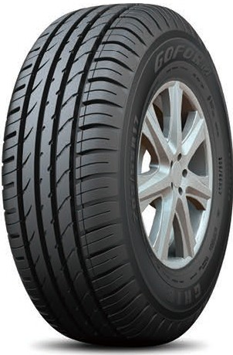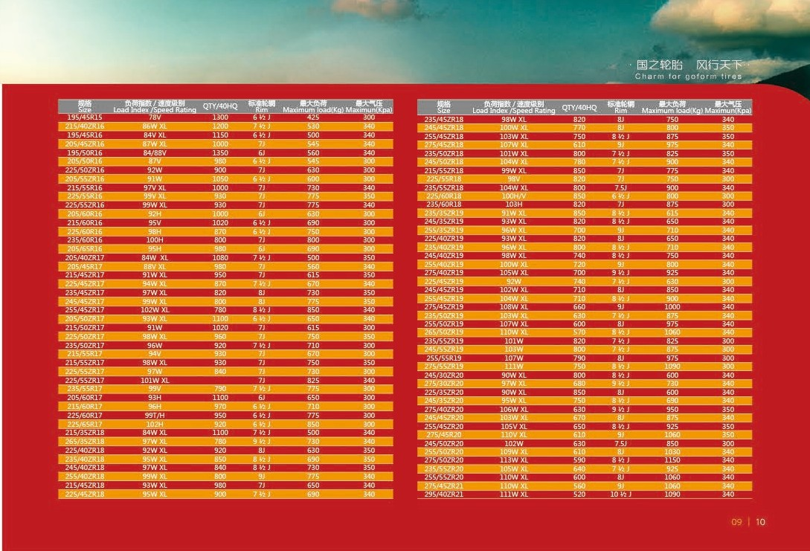

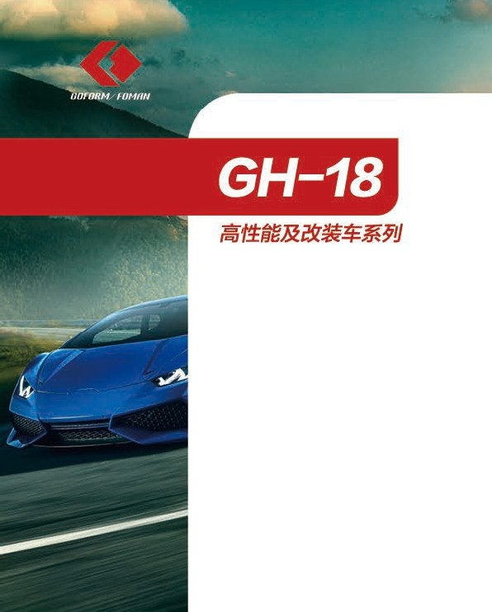

*H,qh performance and1rocJ1fied carsenes*

* iffil!!!lfSllia:l'HO!!ll fl9 tt it. lU f i'iJt.:.lt€i$ i!i le

/Jllffl Wfl\J/i l!UO .it!JJOl:lltsfl\JD'IJ iiitt. ::fflZllJlJlt , GH- 18 H 'f ill i1llfll> ll' "F!lilij U l:lltsttfr.16JB;tJH UMJ tt , i:iJL.:.l ijH ffilllifl\J -€.tt tt l& fl\J-

$'B/l!l.

* U n ique t i r e tread formulation and the pattern **design enab le th e vehicle to have more precision** m an oeuver ab i l it y and b et t er quie t com fo r t . I n addi ti on,GH-18 playswell in both wet and dry conditions while driving with low noiseand is of high comprehensive **performance which can bring your life much fun.**

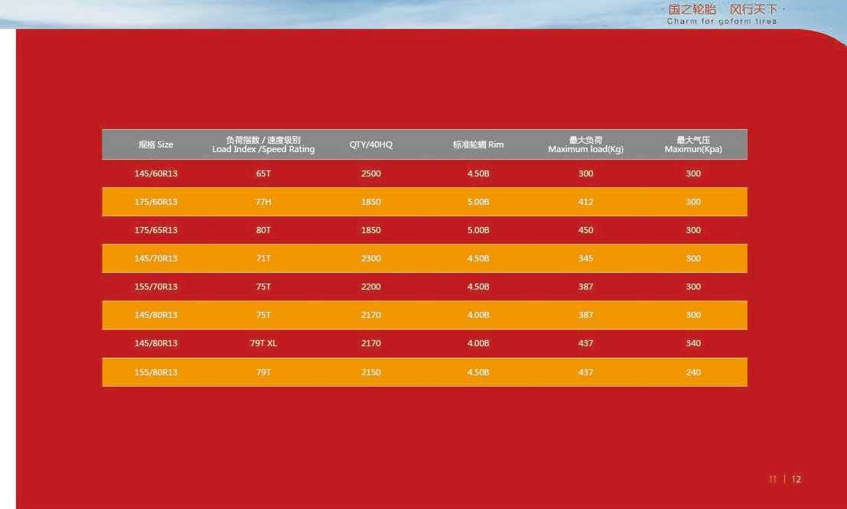



1. *il l/ I/HM NIM/Ill*



*;]F JIJ*

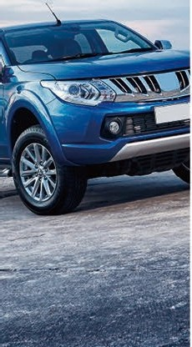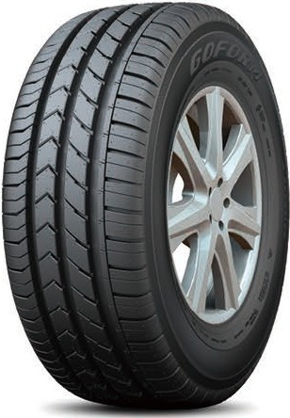F-conom,c series



* + lili ' .!j[ill!:f:Jill(_)i.2,f. ;
* , [£4:i' cp OJ,m ;
* 'p j llJJ..f , lllti il!Jll§j) ;
* mntt :&U oo t.ffl? illl ;
* ft n .m bWtt illltt . i g. fl£.'RillllWJ. !:t ,

rrn .

* Smoo th lines,extraordinary design.
* Quiet comfort.reduce the noise generated in mnning.
* Saving environmenta l pro tection.lower rolling res istance .
* Wide groove an d wide tread design.Shorten braking distanc.e.
* Silicon•co ntaining form ula impro ves co nt rol a nd braking perfo rma nce, red uces noise, reduces rolling resist ance, reduces heat generation and increases range.

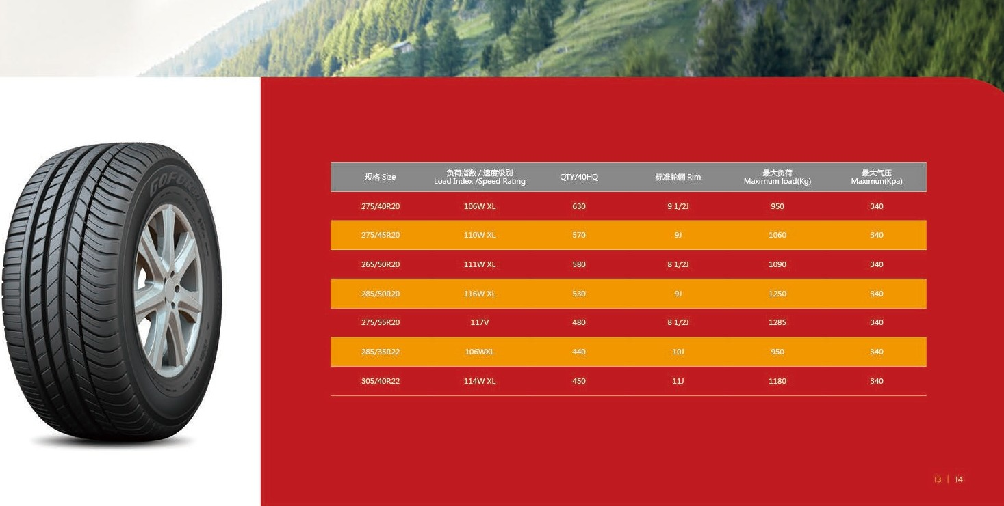



***0 0 1(/HM/ /·I/M f/11***

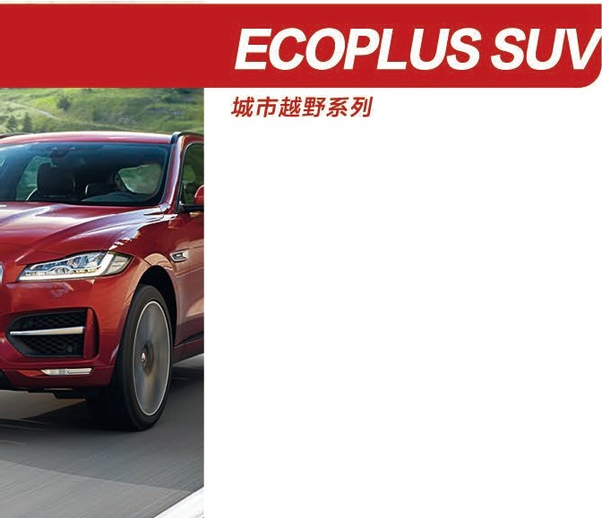

*Urban* cross *country senes*

* H!li!ii, wa +;
* /4iNit ;
* liii'li!n,m
* *i'lm:l!tUfficn* , Hiffl;

□ Jiit:11

, Pffl B , H illl.11:!J ,

*;w> v.,,*, Wtt':i'Hfi.

* **Silent tread,supergrip design.**
* **Accurate control matrix desig n** .
* High den sity silica gel formula,reduceIvelconsumptino.
* **Silicon-containing formula improves control and braking performan,ce reducesnoise, reduces rolling l'esistanc.e, redu ceshea t 9ene ratior1and increases range.**

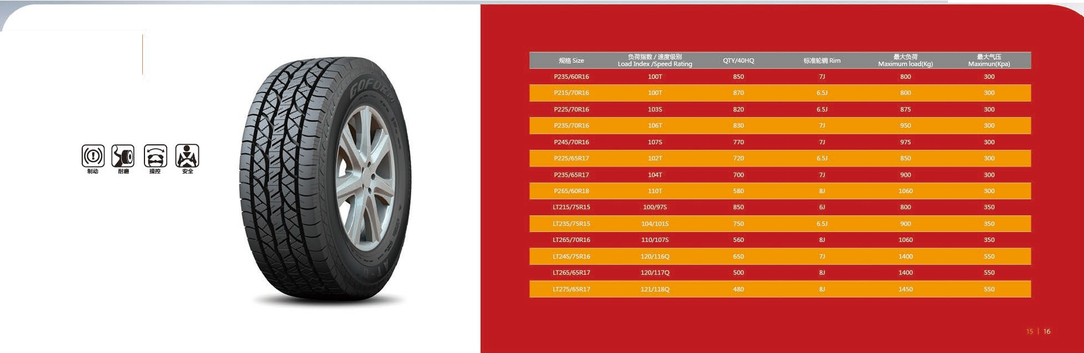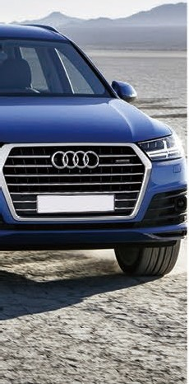

***lill/lJHM II/Ml/II***

## AT-01

***SUV JJ Jlj***

Off-Road Serie

* lH ·;IDl!i!iliJ!Ut!!tt , §flliffl,.lt ;
* i it .:i mlfflW"" li'iWtltt ;
* mll!li!ii i.t' lt'IJJ□iJ(ffi.t.J j;[!jffiJt!!.t.J ;
* t/Mlll!illrJJO , ltf/1Jllj,l * D.k11.
* Super gri p performa nce on wet and dry ground, adapt to

**variousroad conditions.**

* Strong pattern block, overall enhance wear-resistantand stab-resistant.
* Wide tread designed to increasethe loading and griping capacity.
* Zigzag in length and breadth deepen the grooves.enhance drain water and snow ability.
* lil\1Zf£lll:i IXlfi*'"f

**Ch H IU tor go for m !ire s**

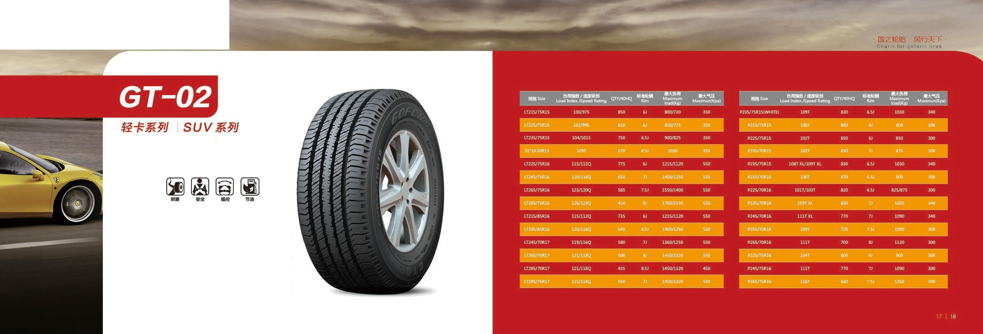

***/ill/ IJHM fl/Ml/II***

I *ignt truck* Tires SUV *Tires*

* t,& ;,l::i'l!J Ef:lmm tt;
  + li t&t>:<l' i!! tt , &7':ll!l tefltll(J" lllitt rommt1 ;
  + ***!itl2n*** , i\lf/i;l ttJlffll,J 11fr., ll>till: ff , fll:ltl

idlllll1J , , Wt-fi'H .

* **Super wear - resi sta nt rubber tread de s ig ned , g rea tly enhanced the wear resistance of the tires.**
* **Jagged centr a l pattern de sig n, g reatly increase the turning of**

the tire rigidity and durability perlonnance .

* **S ilico n- co nta ining formu la improves con tro l and b raking performance,reduces noise, reduces rolling resistance,reduces heat generation and increases range.**

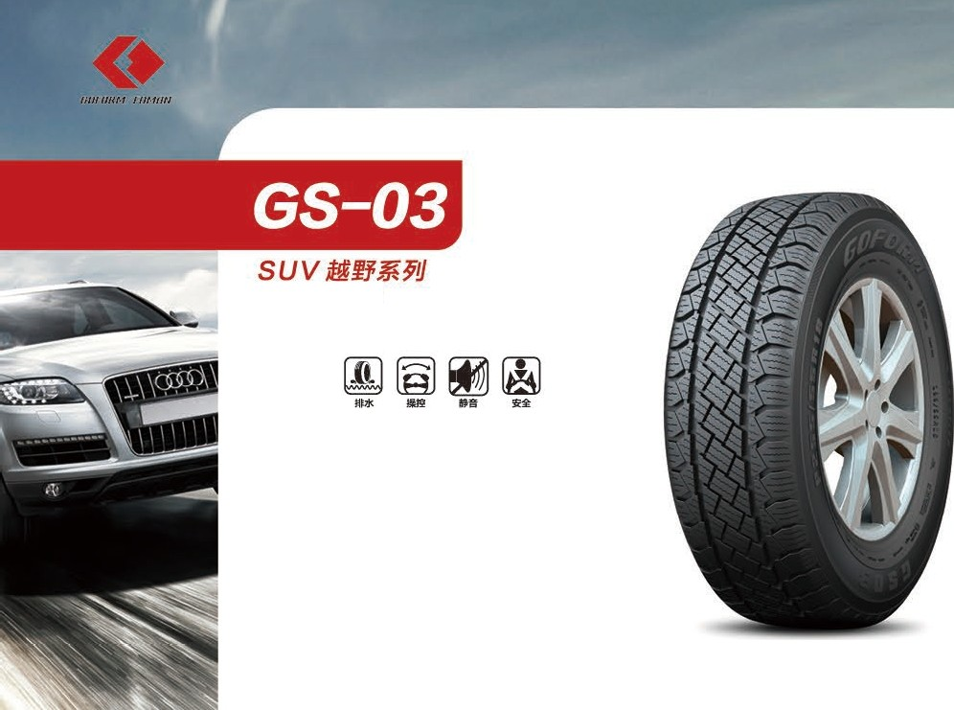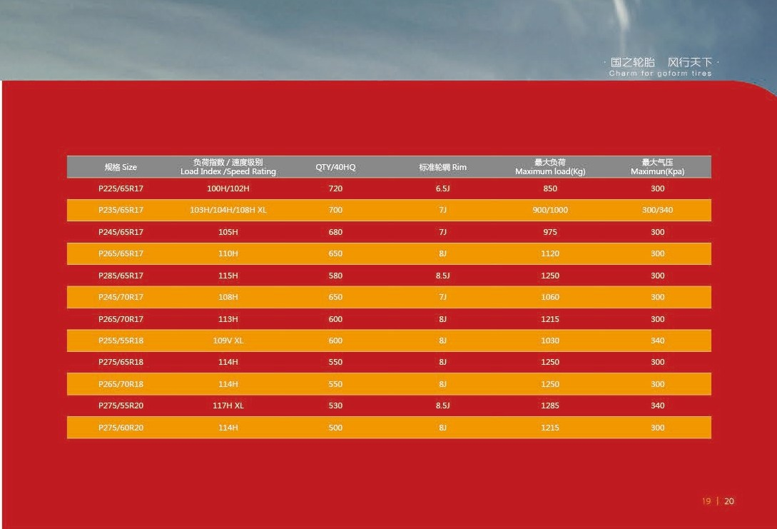

*Ofl Roaa* Series

* Hlf.lilil.lffiU t.ml!il7 1!ai!li1H ;
* '.6' 139Msli. :tt i.!il.ffitld!lls1iltt M:t lol00 liffl:;
* iliiJi l397t!Sl;1;Jl! i. t . ,F /§ffll Di!ttlf!l l39lilF7.l<tt ll:l. i! lll!

.!ilii l39ffl\Jt!!:t.J.

* Special wear resistant t read design.enhanced the wear

**resistanceof *tire.***

* Tight solid tire shoulder decorati ve patte rn desi gn, greatly enhanced the tuming precision of the tire.
* Unique tread pattern groove design, ensuring the drainage performance and excellent grip of the tire

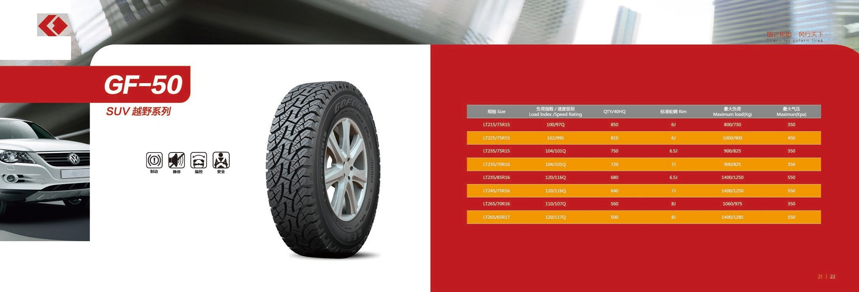

***Jill/ I/UM HIM/Ill***

*Ofl Roaa* Series

* l'£G{ii.Jim&.tR fi!ln;
* -€. ttti'e SUV 99{!tft ?:€!Sl:uttt, l'£fijiijifiJtti.tllllti'e

mit1t 99li1 ttfllm>'l!Ji1 ;

* fii i a15. !Jl $Ui;/JU , 111/,llfllj , llf/lE.t<l

w.l' ' IDl-ffti!fi.

* **Excellen ce perform ance on any roads.**
* **Opt imized pat tern design.su i table for high-perfo rmance**

SUV,excellent ly durable and quiet on any road.

* **Silicon containing formula improves control and braking performance, reduces noise, reduces rolli ng resistance, red u ces heat generation and increasesrange.**

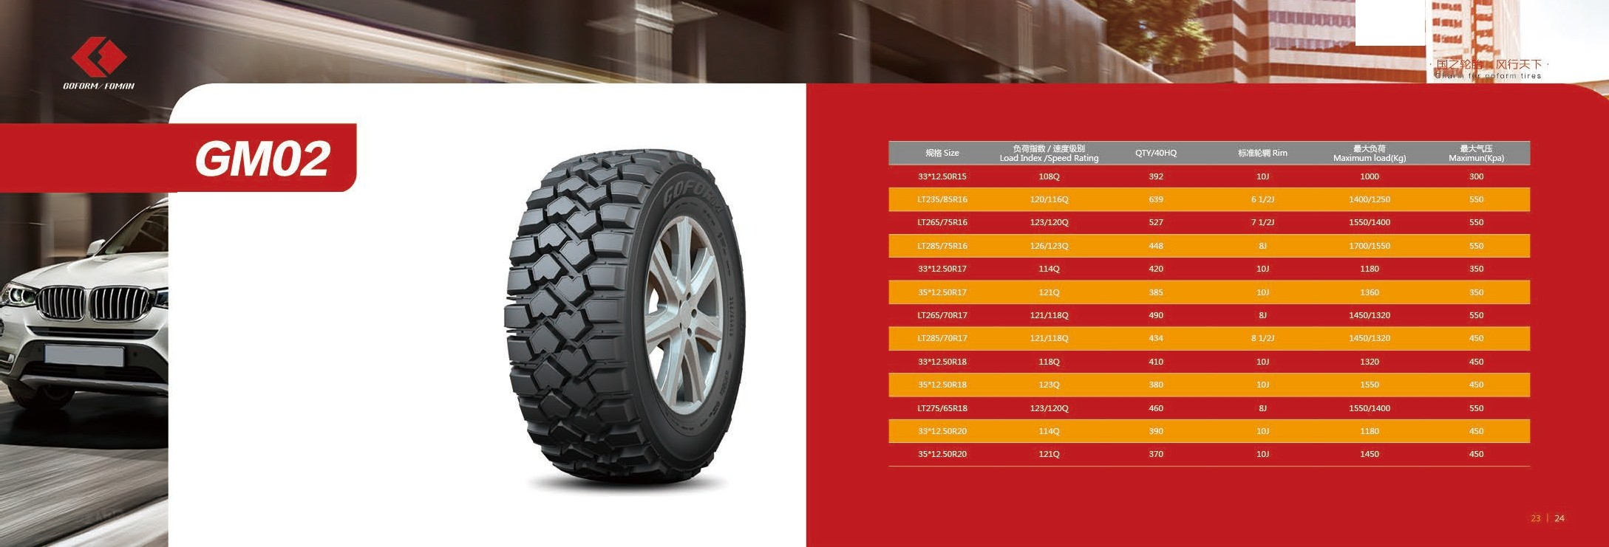

#### lffi!RPJfr$fJ)..J.;f&Jl *!i9 m

*Spec•at for top c1ass off road team and ret,vetl:cle*

[s)(i)

1111! ti u ;5ill!

•e;1;:rett ,faii i'iilf1t i2it,lllilti/e 89 !lilJiUI!

i!ira iLIJ;JJ, !JlUt\lnffilloiliU;

* ll.ml/J!li\'il89* Jiilf!l ffi= D□ JIS i21t, :k89 memHu.wlJU, 8!1i51.89 ;

•JIS iitt 89 i2TT & ffl 89 /J!li\'ili2TT.

jj tJl!lnJ!t!i ;JJ , H :k fl9mi\Yi1i 19:lm ;

* lll-tli!!JfflAA t.t&:k89m tt.
* Huge patt ern block and pattern groove optimi zati on combination design, provide excellent non -paved road d riving force, grip and anti-skid performance;
* Doub le • ply reinforced bel ts and special specification three• ply reinforced tire body design, which greatly increases the overall strength of tires to meet the requirements of the worst

roa d co nditions;

* Specific protection dam des ign of tire shoulder pattern and reinforcement design of rough mineral tire to improve the impact resistance of shoulder, thus great ly improving the durabi lity.
* Single twined hexago nal tyre design great ly improves th e

dvrobility **of the tyre** rim,



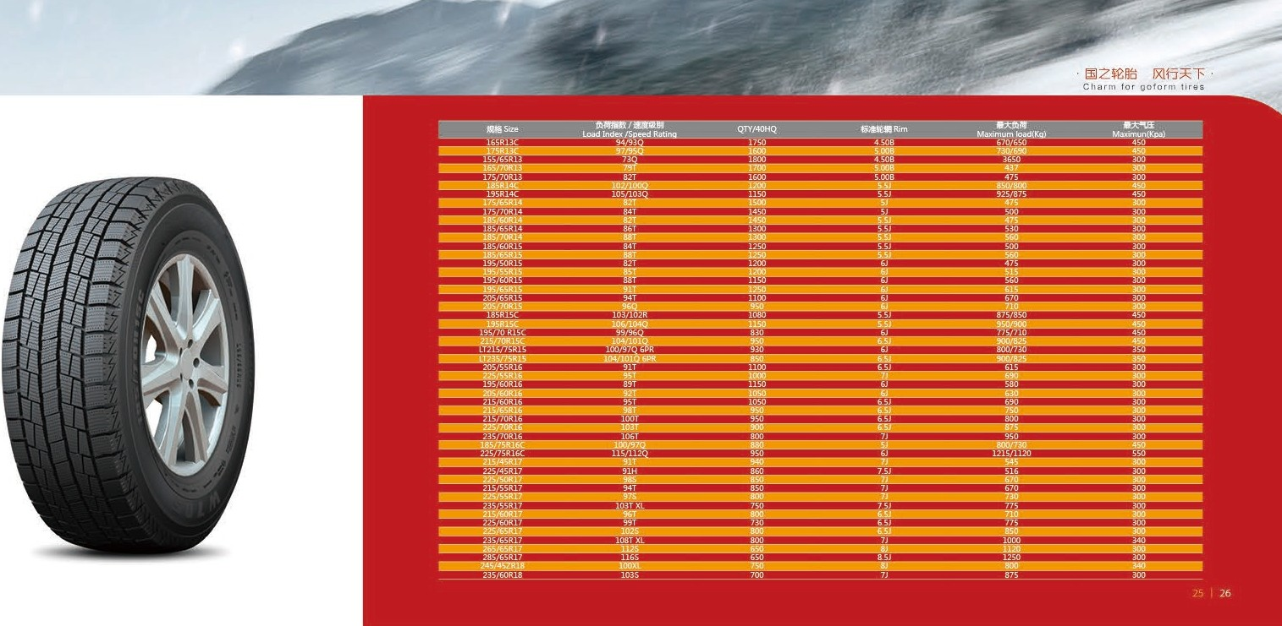*I.ill! I/HM l·IIMf/f l*

## W705

### itB/JtJ

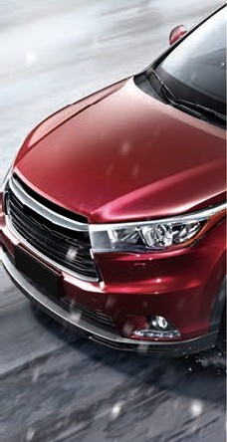*5now T,res*



##### - n.m afl£ tt m

###### It ;

* **t**' **im,F/.m)il ffl;**

-re \2i.tmm rrff, ru1 ett;

* + t!iifl)jcn , mli!i 11113,a,1ao11113, llfff£DJ\le1t, P¥ffl;

m;:,,*;r,* ,

* + Use of special rubbe r formula improves the wet grip and skid resistance .
  + Un ique patte rn design avoids irregula r tread wear of read.
  + Unde r pre cisio n calc ulatio, n W705 pat ten ensures good maneuverab ility and low noise,
  + Silicon•conta ining fo rmula imp roves co ntrol and braking performa nce, reduces noise, reduces rolling res istan ce, reduceshealgeneration and increases range.

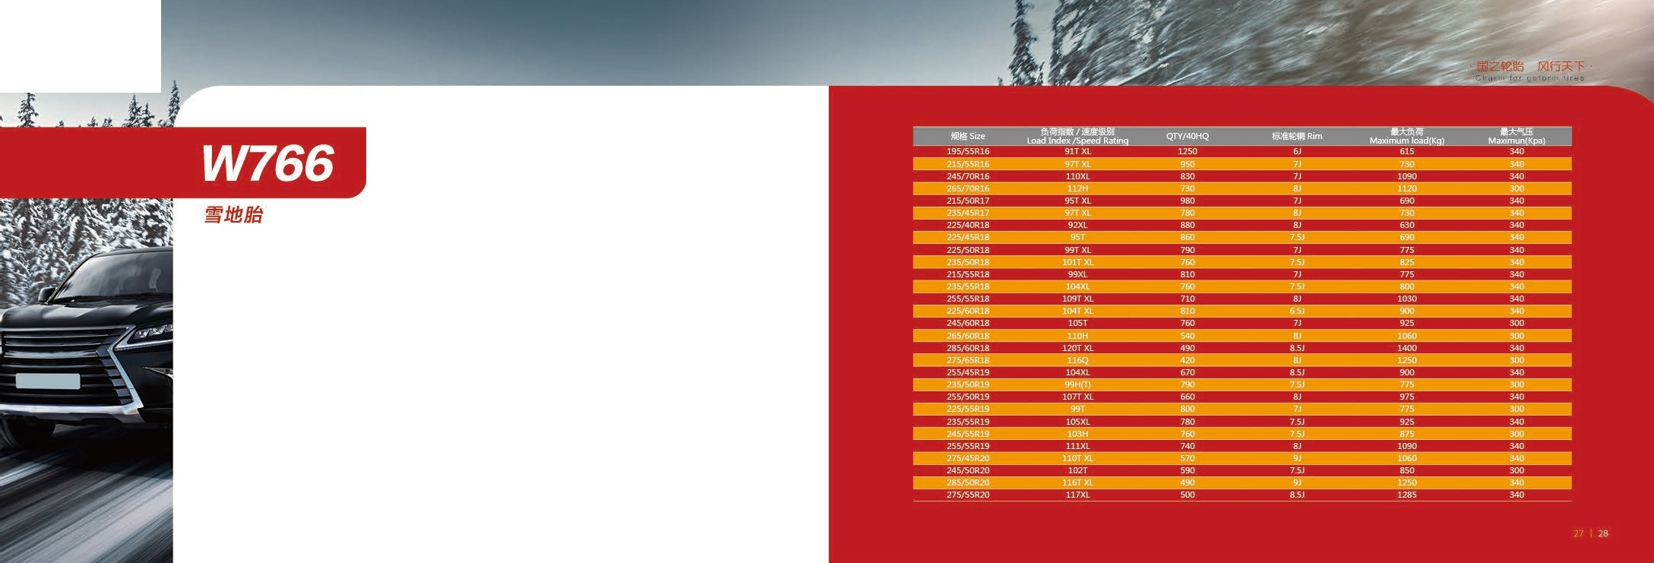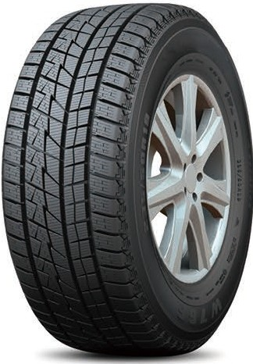

*till/ /JHM l·lll •flll l*

5now T,res

* + - 89 tl!unt.!lffiteMi 'li;
* n munt. m mi n;
* 3Dnfflre rr. nro

ttm ii ;

* + ;; ie tl! it , ffi+1':mii.i iu. lillllll

ila2 .

* + The la rge block pattern designs imp rove tire handling perfonnance.
  + The crossed trench design provide stable gripping in the snow

road.

* + Dense 30 patte rn design for excelle nt gripping and control performance against snow.
  + The multi pitch pattern block designs by compute r simulation analysis of reaso nable arrangemen effective reduce the tire noise.

*liO I II HM l·IIM f/11*

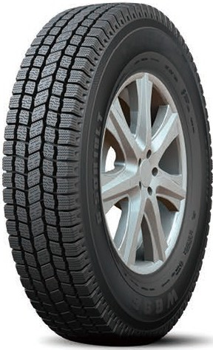***W696***

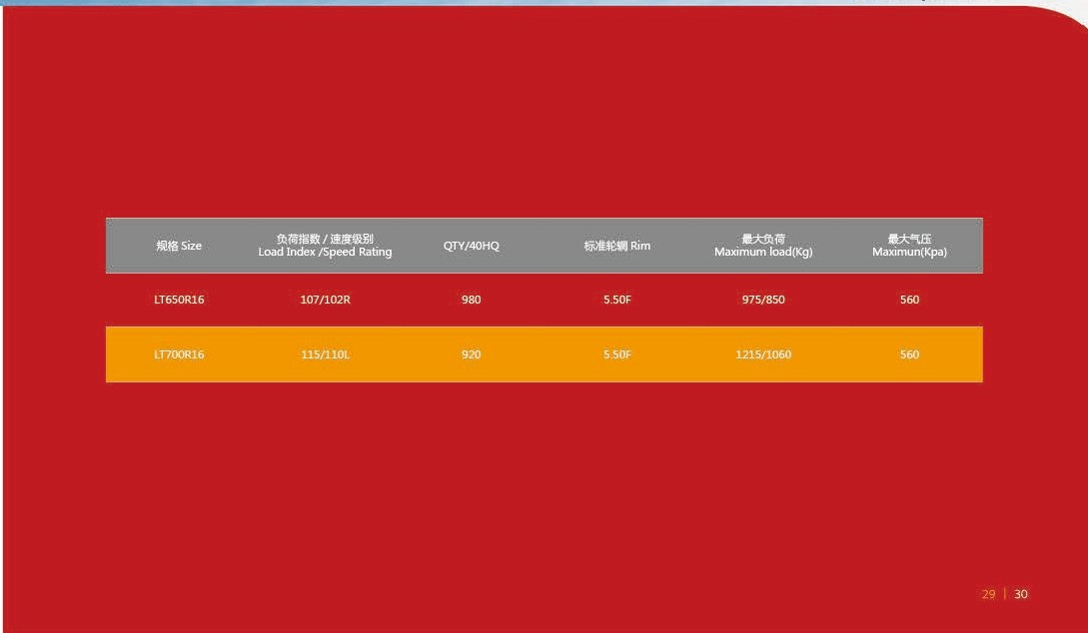

### itB/JtJ

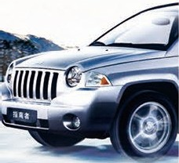5now T,res



* IIUtt tll .;; , i¥ -ill;

\2it. , mag M5lt.JJ.il.iffi-1 t.J ;

* fe i!M. **i@jg lllutl**

:ffj/2t.i\\2i.t. 6Ml flliliTll\JU:il!/Jllfffl;

* **f0!i§lt!!:Mill,** ciJII

3 m::k89:tetlt \2i.t, lliH!ts!008\li4P.K , Hliilffi MafJ11fffl.

* Rigid pattern distrib utio n for long life

Designed with a cent ral pattern, a solid tire body ensures traction and

durability

* Unique design for higher load handling

The reasonable toot h - shaped rim design makes the performance of the

tire better under high load.

* Exce lle nt snowbrake, safe and reliable

Three wide pattern grooves a re designed to provide bette r d rainage and ensure optimal snow braking performance

###### Zrelll.:i 1Xl63::'"f

C ha r m for go f o r m ti re s

